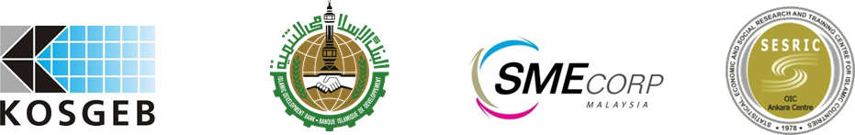

WORKSHOP ON ENHANCING THE COMPETITIVENESS OF SMALL AND MEDIUM SIZED ENTERPRISES IN THE OIC MEMBER STATES

Ankara Hilton Hotel
Ankara, 12-14 June 2012
REGISTRATION FORM
(Please fill in this form in capital letters and return one copy to:
training@sesric.org and/or fax: +90 (312) 467 34 58
Latest by 15 May 2012)

Country / Institution:
Family Name:
First Name:
Position:
Phone:
E-mail:
Fax:
Mobile Phone:
Arrival Details |  |  | Departure Details
Date | Time | Flight No | Date | Time | Flight No
Flight Schedule:

Date: Signature:

